Forecasting and Recommendations

- Sales Forecasting

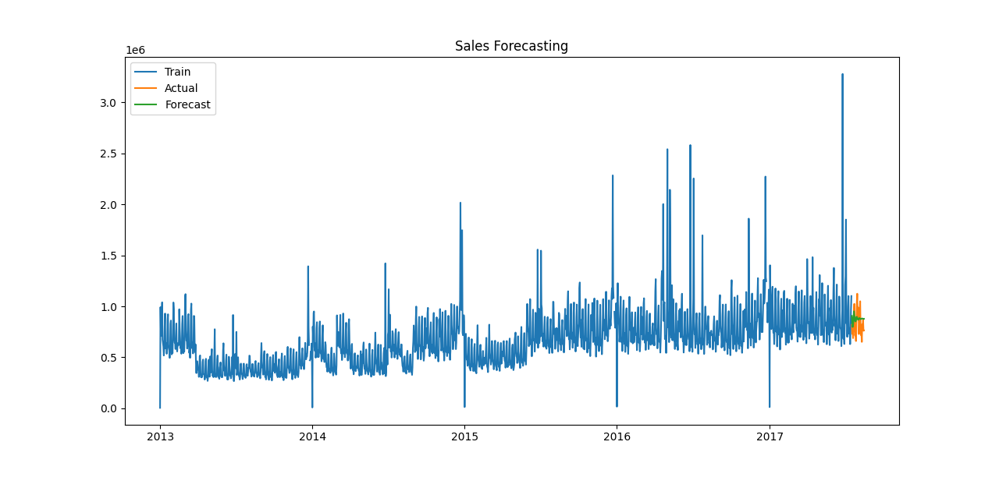

- Forecast Future Sales

